Florence Eastman

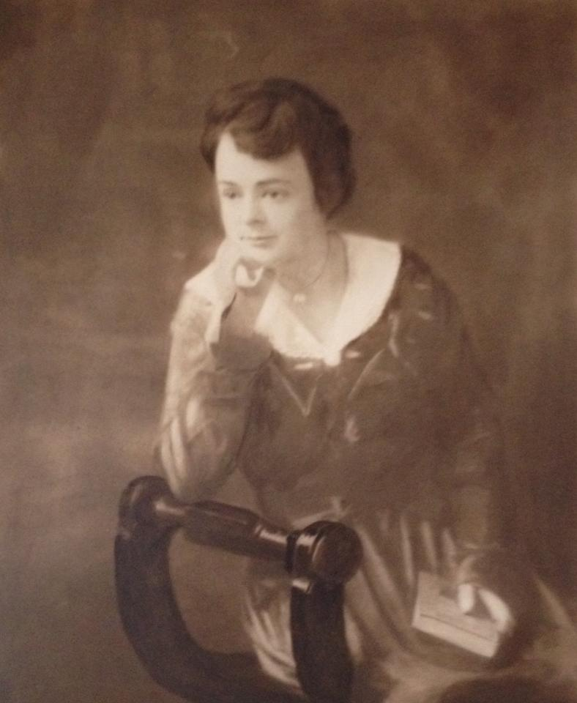
Photo credit: American Legion Florence Eastman Post 280

The only woman to enlist during World War I from Mattapoisett, Florence Eastman (1894-1918) was a strong, passionate, self-disciplined woman. Born in 1894 in Somerville, Florence spent a great deal of her life in East Falmouth before moving to Mattapoisett. She was an only child who lived with her parents, Russell and Ada Atwood Eastman. Florence’s father was the keeper of the Ned’s Point Lighthouse from 1916 to its closure in 1923. In 1911, when she was just 17 years old, Florence was trained as a nurse at Morton Hospital in Taunton. She later completed post graduate courses at Massachusetts General Hospital. Florence spent much of her time as a night supervisor in New England hospitals.

In order to enlist as an army nurse, Florence decided to join the Red Cross. In 1918, she was assigned to a Base Hospital in Camp Upton, Long Island, New York. She was transferred to Camp Mills, Mineola, Long Island, where she became the Head Army Nurse of the Isolation Hospital with 20 nurses and over 100 orderlies under her supervision. The American Legion Florence Eastman Post 280 website confirms that “Her devotion to duty, her sympathy for the sick soldiers and her consistent, cheerful disposition won the respect and esteem of all with whom she was associated.” However, since she was around people who were constantly ill, she herself caught the Spanish Influenza in 1918. Florence was one of the 500 million people worldwide to catch this terrible disease, which ended her life early at age 24 on October 14, 1918. She was buried at Pine Island Cemetery in Mattapoisett with full military honors. She was the only Mattapoisett volunteer to not return from military duty during World War I.

Florence was remembered not only as a nurse during World War I but also as a friend to her patients. Florence had an extreme devotion to her job, and she always strived to bring positivity into the eyes of everyone she was with. She was a caring young woman who had helped several soldiers fight through their troubles. In 1925, the Florence Eastman Post of the American Legion was named in her honor. Florence Eastman was truly a role model in committing her life to serving the ill and injured during World War I.

Alison Cox
with Ann O’Leary

Information from

Lamoureaux, Michael P. “Post 280 History: Florence Eastman, Army Nurse.” American Legion Florence Eastman Post 280, http://www.florenceeastmanpost280.org/history.html.
Ray, Andrea. “Florence Eastman: From Ned's Point Lighthouse to World War I.” Sippican Week, 25 Nov. 2017, https://sippican.villagesoup.com/p/florence-eastman-from-neds-point-lighthouse-to-world-war-i/1706860.
Ryan, Mary J. “Florence Eastman.” The United States World War One Centimental Commission, www.worldwar1centennial.org/index.php/commemorate/family-ties/stories-of-service/1415-florence-eastman.html.
.

